**The Political Economy of Chinese Aid: Does Poverty Predict Cooperation Results, and What Influences the Effect?**

**1. Introduction**

Over the past two decades, China's global infrastructure investment and foreign aid have expanded significantly, especially under the Belt and Road Initiative. While the traditional model of foreign aid prioritizes needs-based allocation - favoring poorer countries - China's aid strategy seems to follow a different logic. This study examines the extent to which poverty predicts aid distribution in China and whether this relationship is modulated by the type of regime a country has.

Understanding these patterns is critical for both recipient countries and policymakers. If aid is directed primarily to meet economic needs, it reinforces China's narrative of South-South cooperation and global development assistance. However, if aid is strategically distributed based on political and economic interests, it suggests a more geopolitically motivated pattern. This study examines these conflicting explanations by assessing the relationship between extreme poverty and Chinese aid, while considering the role of authoritarianism in shaping cooperation risks.

**2. Theory and Hypotheses**

Two very different theoretical perspectives can explain China's aid distribution pattern.

1) Development hypothesis:

Aid allocation should give priority to low-income countries, which have greater financial needs.

If China follows the logic of development, an increase in extreme poverty levels should be associated with an increase in aid distribution.

**Hypothesis 1 (H1): Countries with higher extreme poverty rates receive more Chinese aid.**

1. Political Constraints Hypothesis:

Authoritarian regimes can pose higher cooperation risks due to weak governance, corruption, and abrupt policy changes.

Even with high levels of poverty, China may be hesitant to provide aid to authoritarian countries for fear of breach of contract or instability.

**Hypothesis 2 (H2): The positive effect of poverty on aid allocation is weaker in autocratic regimes, where governance risks hinder cooperation.**

If both hypotheses hold, it suggests a conditional relationship—poverty alone does not predict aid, but its effect depends on political regime characteristics.

**3. Data Description**

The study integrated data from two primary sources:

1) China's Foreign Aid Database (2000-2021) : provides project-level aid flows by industry.

2) Global Economic Indicators (2013-2023) : including key macroeconomic and governance variables such as:

Extreme poverty rate (proportion of population below the poverty line)

Corruption Perception Index (Transparency International)

Gini coefficient (Income inequality)

GDP per capita (World Bank)

Democracy Index (Economist Intelligence Unit)

To ensure causal validity, all economic and governance indicators are presented before dependent variables for 2013-2018 (China Aid, 2019-2021). Aid data are aggregated at the country level, distinguishing between total aid and aid in specific sectors (education, agriculture, commerce, communications, etc.). Missing values are replaced with 0, indicating that no aid was received, and historical aid levels (2013-2018) are taken into account for path dependence.

**4. Methodology**

The regression analysis follows a stepwise modeling approach, progressively adding controls:

Bivariate Model (M1): Estimates the direct relationship between extreme poverty and aid allocation.

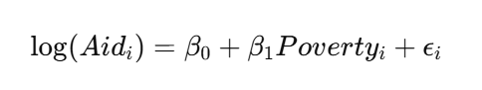

Economic Controls (M2-M3): Introduces Gini index, GDP per capita, and corruption perception index to isolate the role of poverty.

Political Controls (M4-M5): Adds political regime type and democracy index to test governance effects.

Interaction Model (M6): Includes Extreme Poverty × Autocracy, testing whether autocratic states receive less aid when poverty is high.





Baseline Aid (M7): Controls for historical aid (2013-2018) to identify path-dependent patterns.

All regressions use robust standard errors (HC2) to correct for heteroskedasticity. The dependent variable (total aid received) is log-transformed to normalize its skewed distribution. Finally, we regression China's aid by industry and verify the robustness of regression including all variables.

**5. Findings**

Graph 1: Chinese Aid and Extreme Poverty

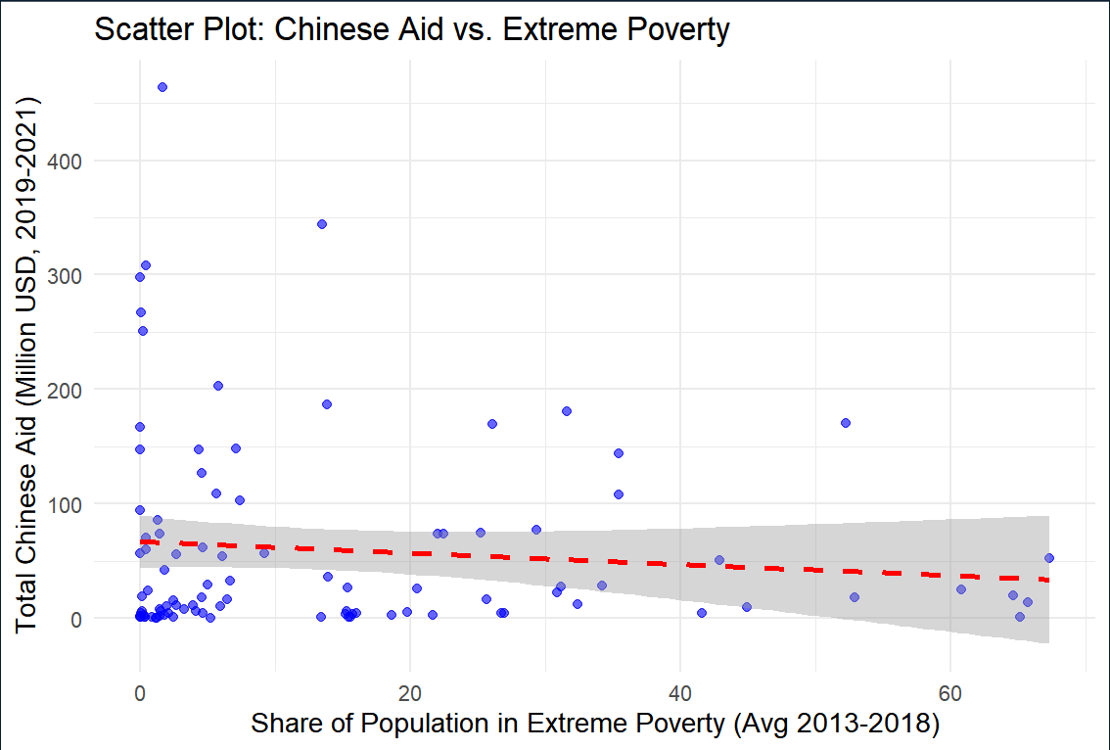

The scatter plot suggests a weak negative relationship between extreme poverty and aid allocation. While some low-income countries receive substantial aid, many recipients have relatively low poverty levels, indicating that China’s aid strategy is not solely poverty-driven. The dispersion of data points suggests that other factors—such as economic stability and political alignment—play a role in aid distribution.

Table 1: Baseline Regression Results

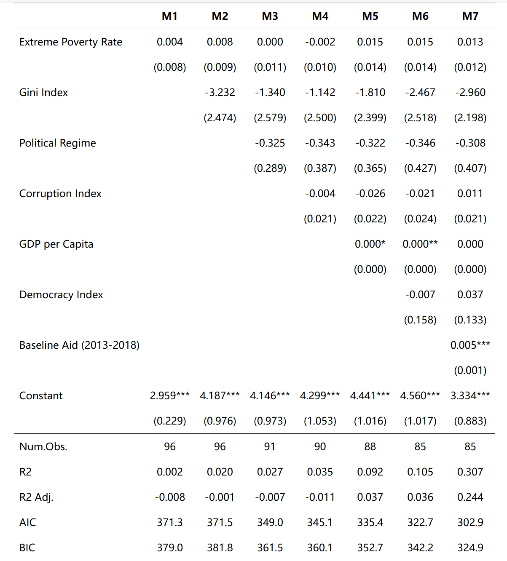

The bivariate regression (M1) does not find a significant correlation between poverty and aid. Adding economic controls in M2-M3 shows that GDP per capita is positively associated with aid, meaning wealthier countries receive slightly more funding. Governance indicators (corruption perception, democracy index, political regime) remain insignificant, suggesting that China does not systematically favor democratic or less corrupt countries in its aid decisions.

However, the historical aid variable (M7) is highly significant, confirming that past aid flows (2013-2018) strongly predict future aid (2019-2021). This suggests a path-dependent model, where aid is allocated based on long-term partnerships rather than shifting economic needs.

Table 2: Interaction Effects (Extreme Poverty × Autocracy)

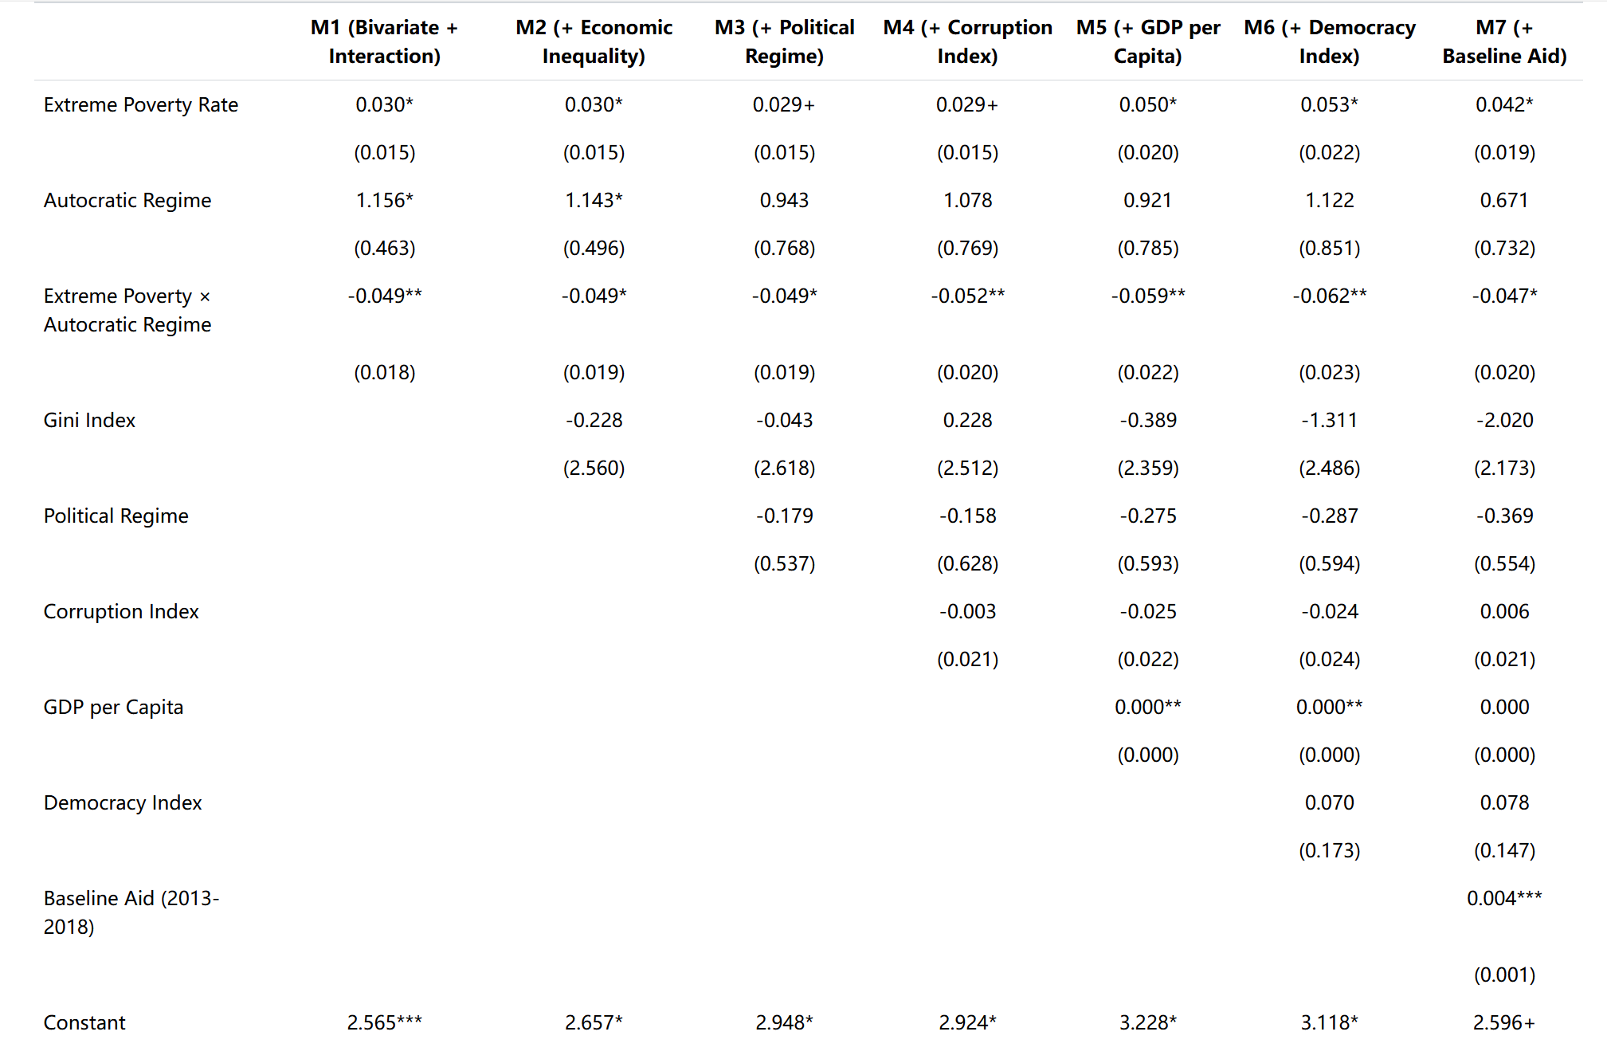

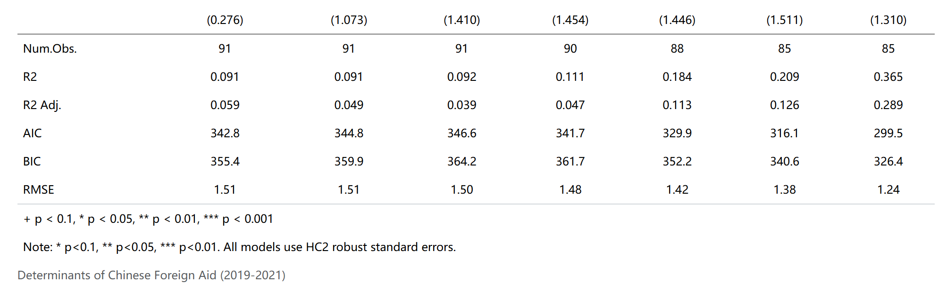

When the interaction term is introduced (M6), it is negative and statistically significant, meaning that autocratic regimes receive significantly less aid when poverty levels are high. In contrast, non-autocratic states experience a stronger poverty-aid relationship—suggesting that China avoids allocating large aid flows to highly impoverished autocratic regimes, likely due to governance risks and instability.

Table 3: Sector-Specific Analysis

Business Agriculture

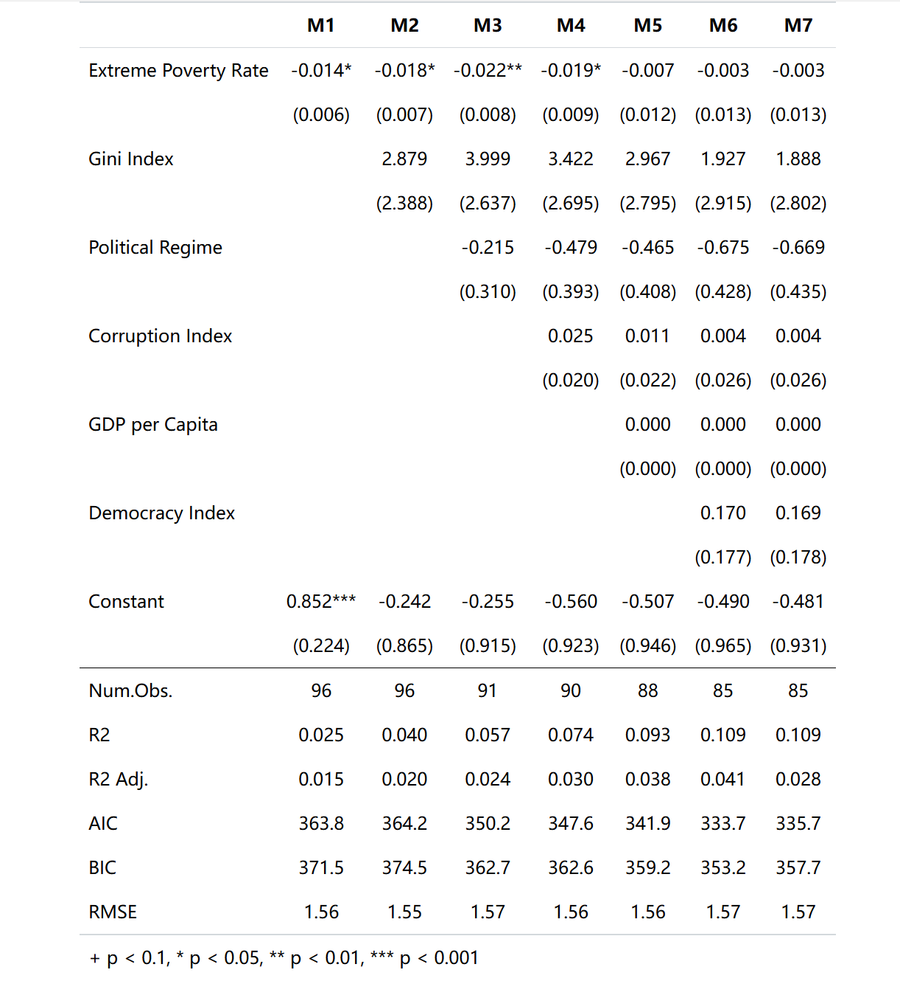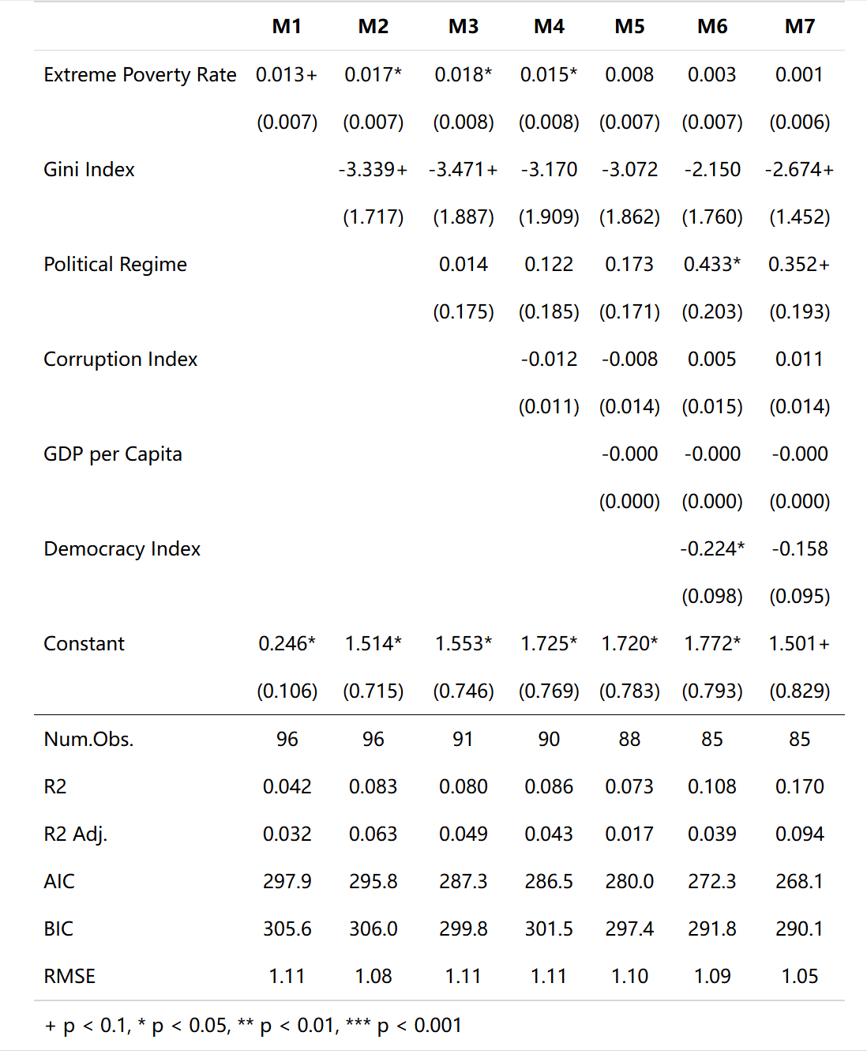

Using log-transformed aid data, we regressed every sector’s aid data. Sector-specific regressions reveal some meaningful results:

Education & Agriculture: Extreme poverty initially correlates with more aid, but the effect diminishes when governance controls are added.

Business & Financial Services: Aid is more correlated with political stability than poverty levels.

Communications: Historical aid (2013-2018) is the strongest predictor, confirming a path-dependent pattern in China’s infrastructure financing.

Overall, poverty does not systematically drive aid allocation, and sectoral aid decisions depend on economic and political factors.

**6. Limitations and Conclusion**

While the analysis provides insights into China’s aid strategy, several limitations must be noted:

Omitted Variables: Factors such as geopolitical alliances, trade partnerships, and military cooperation are not fully accounted for.

Measurement Issues: The Political Regime Index simplifies governance characteristics and does not capture informal power dynamics.

External Validity: Results apply only to Chinese aid and may differ from Western-led aid models.

Despite these limitations, findings suggest that China’s aid is not strongly driven by poverty reduction. Instead, political stability, economic viability, and historical partnerships shape allocation patterns, with autocratic regimes receiving less aid when poverty is high.

**7. Appendix: Regression Diagnostics**

Multicollinearity (VIF Test): All variables have VIF < 5, confirming no severe multicollinearity. The values are listed below:

share.of.population.in.extreme.poverty_avg

2.149967

economic.inequality.gini.index_avg

1.430359

political.regime_avg

2.306712

ti.corruption.perception.index_avg

2.715457

gdp.per.capita.worldbank_avg

2.929884

democracy.index.eiu_avg

3.084516

aid_all_sector_baseline

1.447465

Autocorrelation (Durbin-Watson Test): p = 0.4317, indicating no serial correlation.

Homoscedasticity (Breusch-Pagan Test): p = 0.7977, confirming constant variance.

Residual Analysis: Histogram and Q-Q plot suggest reasonably normal residuals with minor deviations. The Residuals vs. Fitted plot shows that residuals are mostly centered around zero but exhibit slight curvature, suggesting mild non-linearity. The histogram of residuals indicates an approximately normal distribution with some moderate fluctuations. The log transformations of extreme poverty and aid effectively reduce skewness, supporting the validity of the regression model.

Outlier Analysis: Identified 8 moderate outliers but no extreme leverage points, confirming result stability.

These tests confirm that the regression models meet key statistical assumptions, ensuring the reliability of findings.